2020. 7. 9. WEB222 - Week 7 | web222

[**web222**](https://web222.ca/)



**WEB222 - Week 7**



**From HTML to the DOM**



Web pages rely on HTML for their initial structure and content. We write web pages using HTML, and then use web browsers to parse and render that HTML into a living (i.e., modifiable at runtime) tree structure. Consider the following HTML web page:

The DOM Tree is a living version of our HTML.

**<!DOCTYPE html>**

<html>

<head>

<title>This is a Document!</title>

<meta charset="utf-8">

</head>

<body>

<h1>Welcome!</h1>

<p>This is a paragraph with a <a href="index.html">link</a> in it.</p>

<ul>

<li>first item</li>

<li>second item</li>

<li>third item</li>

</ul>

</body>

</html>

The browser will parse and render this into a tree of nodes, the [DOM Tree](https://en.wikipedia.org/wiki/Document_Object_Model):

https://web222.ca/weeks/week07/ 1/32

2020. 7. 9. WEB222 - Week 7 | web222

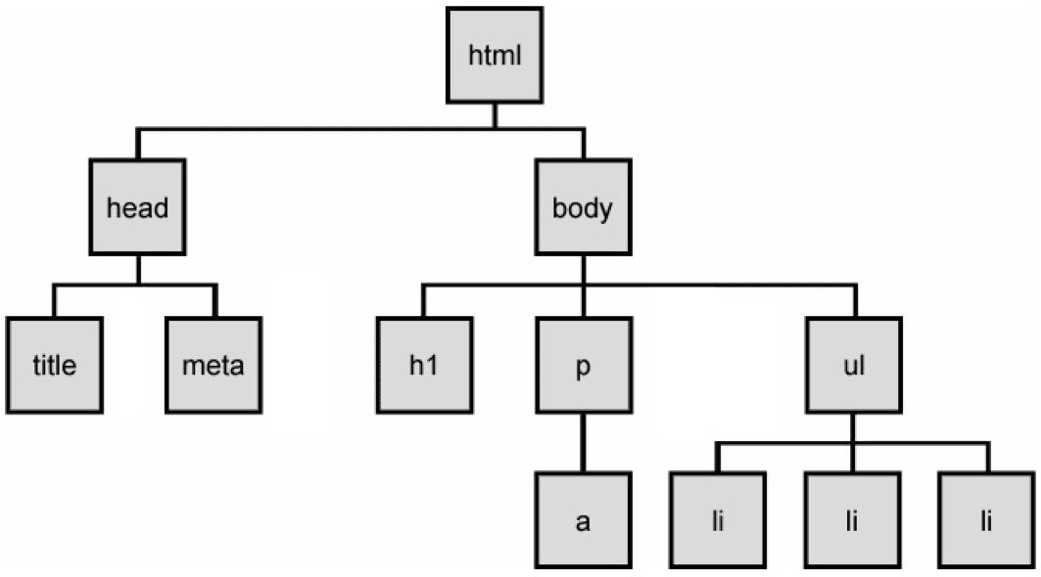

The DOM Tree is made up of DOM Nodes, which represent all aspects of our document, from elements to attributes and comments. We’ll refer to nodes and elements interchangeably, because all elements are nodes in the tree. However, there are also other types of nodes, for example: text nodes (the text in a block element) and attribute nodes (key/value pairs). We don’t always show every node in our diagrams. Consider the <p> element from the example above:

<p>This is a paragraph with a <a href="index.html">link</a> in it.</p>

https://web222.ca/weeks/week07/ 2/32

2020. 7. 9. WEB222 - Week 7 | web222

Here are the nodes that would be created:

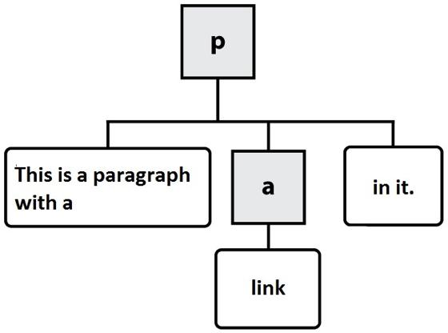

In this diagram, the gray, square boxes represent element nodes, while the white, rounded boxes are text nodes.

When we load a web page in a web browser, we see its fully parsed and rendered form. The web browser *begins* with the initial content we provide in our HTML. We can see the initial source HTML for any page we visit, whether we authored it or not:

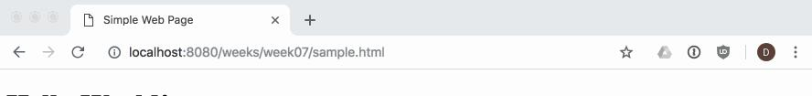

https://web222.ca/weeks/week07/ 3/32

2020. 7. 9. WEB222 - Week 7 | web222

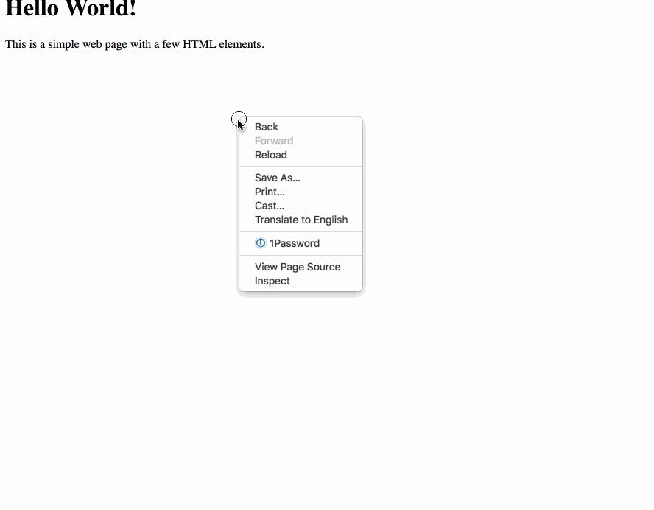

https://web222.ca/weeks/week07/ 4/32

2020. 7. 9. WEB222 - Week 7 | web222

Our DOM Tree gets its name because of its shape: a *root* element connected to *child* nodes that extend like the branches of a tree. This tree structure is how the browser views our web page, and is why it is so important for us to open and close our HTML tags in order (i.e., our tags define the structure of the tree that the browser will create at runtime).

As web developers we can see and interact with the DOM tree for a page using the browser’s built-in developer tools:

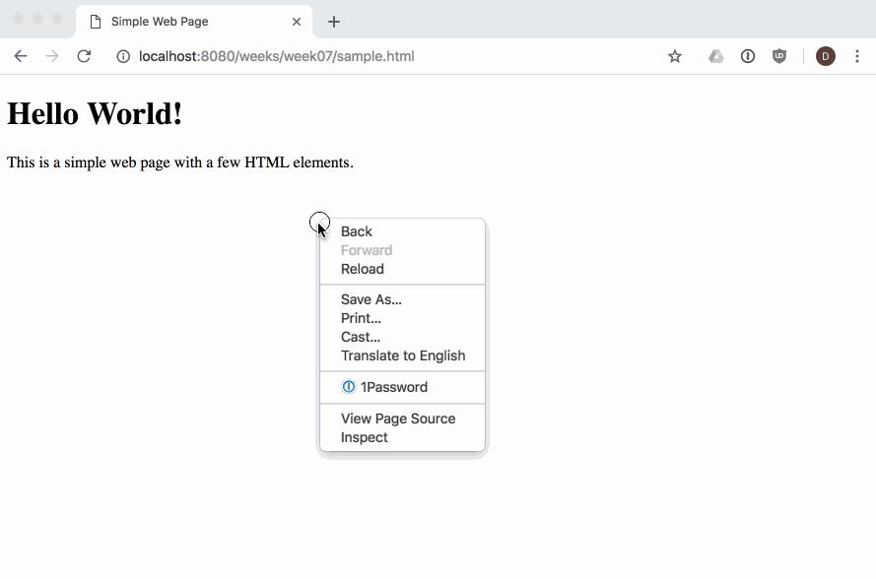

https://web222.ca/weeks/week07/ 5/32

2020. 7. 9. WEB222 - Week 7 | web222



The dev tools allow us to [view and work with](https://developers.google.com/web/tools/chrome-devtools/beginners/html) the parsed DOM elements in a page. We can also use the dev tools to visually select an element in the page, and find its associated DOM element:

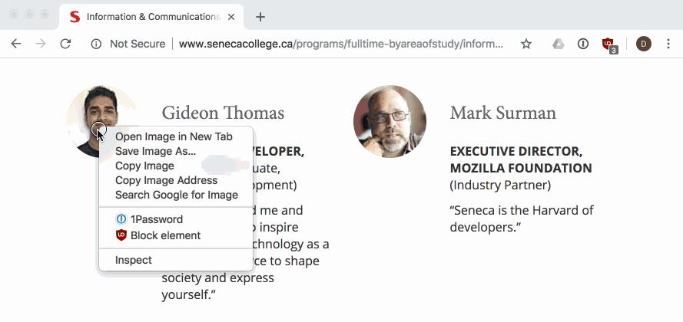

https://web222.ca/weeks/week07/ 6/32

2020. 7. 9. WEB222 - Week 7 | web222



NOTE: it’s a good idea to get experience using, and learn about your browser’s dev tools so that you can debug and understand when things go wrong while you are doing web development. There are a number of guides to help you learn, like [this one from Google](https://developers.google.com/web/tools/chrome-devtools/).



**Programming the DOM**



Web pages are dynamic: they can change in response to user actions, different data, JavaScript code, etc. Where HTML defines the initial structure and content of a page, the DOM is the *current* or *actual* content of the page as it exists right now in your browser. And this can mean something quite different from the initial HTML used to load the page.

Consider a web page like GMail (or another email web client). When you visit your Inbox, the messages you see are not the same as when your friend visits hers. The HTML for GMail is the same no matter who loads the page. But it quickly changes in response to the needs of the current user.

https://web222.ca/weeks/week07/ 7/32

2020. 7. 9. WEB222 - Week 7 | web222

So how does one modify a web page after it’s been rendered in the browser? The answer is DOM programming. We’ve been using this “DOM” acronym without defining it, and its high time we did.

The [Document Object Model (DOM)](https://developer.mozilla.org/en-US/docs/Web/API/Document_Object_Model/Introduction) is a programming interface (i.e., set of Objects, functions, properties) allowing scripts to interact with, and modify documents (HTML, XML). The DOM is an object-oriented representation of a web page. Client-side web programming is essentially *using* the DOM via JavaScript to make web pages *do* things or *respond* to actions (e.g., user actions).

You may have noticed in our work with JavaScript that there was nothing particularly “webby” about it as a language: we wrote functions, worked with arrays, created objects. Lots of programming languages let you do this. JavaScript can’t do anything with the web on its own. Instead, we need to access and use the Objects, functions, and properties made available to us by the DOM using JavaScript.

As web programmers we use the DOM via JavaScript to accomplish a number of important tasks:

1. Finding and getting references to elements in the page
2. Creating, adding, and removing elements from the DOM tree
3. Inspecting and modifying elements and their content
4. Run code in response to events triggered by the user, browser, or other parts of our code

Let’s look at each one in turn.

**Finding elements in the DOM with JavaScript**

Our entry point to the DOM from JavaScript is via the global variable [window](https://developer.mozilla.org/en-US/docs/Web/API/Window) . Every web page runs in an environment created by the browser, and that environment includes a global variable named [window](https://developer.mozilla.org/en-US/docs/Glossary/Global_object#window_object_in_the_Browser) , which is provided by the browser (i.e., we don’t create it).

There are hundreds of Objects, methods, and properties available to our JavaScript code via window . One example is [window.document](https://developer.mozilla.org/en-US/docs/Web/API/Document) , which is how we access the DOM in our code:

* *Access the document object for our web page, which is in the current window* **var** document **=** window.document;

https://web222.ca/weeks/week07/ 8/32

2020. 7. 9. WEB222 - Week 7 | web222

NOTE: since properties like document are available on the global window object, it is common to simply write document instead of window.document , since the global object is implied if no other scope is given.



Our document’s tree of elements are now accessible to us, and we can access a number of well-known elements by name, for example:

* *Get the value of the document's <title>* **var** title **=** document.title;
* *Return a reference to the document's <body> element* **var** body **=** document.body;
* *Return a list of all <a> elements in the document* **var** hyperlinks **=** document.links;
* *Return a list of all the <img> elements in the document* **var** images **=** document.images;

There are lots more. We can easily experiment with these in the dev tools web console, where we can access our window object. For example, here is the web page <https://unsplash.com/search/photos/toronto>with the web console open, and the result of window.document.images is shown, 41 <img> elements are returned in a collection:

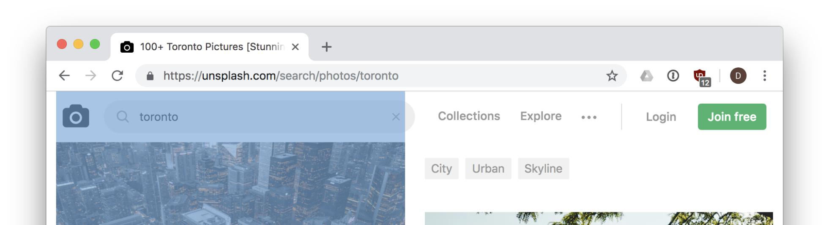

https://web222.ca/weeks/week07/ 9/32

2020. 7. 9. WEB222 - Week 7 | web222

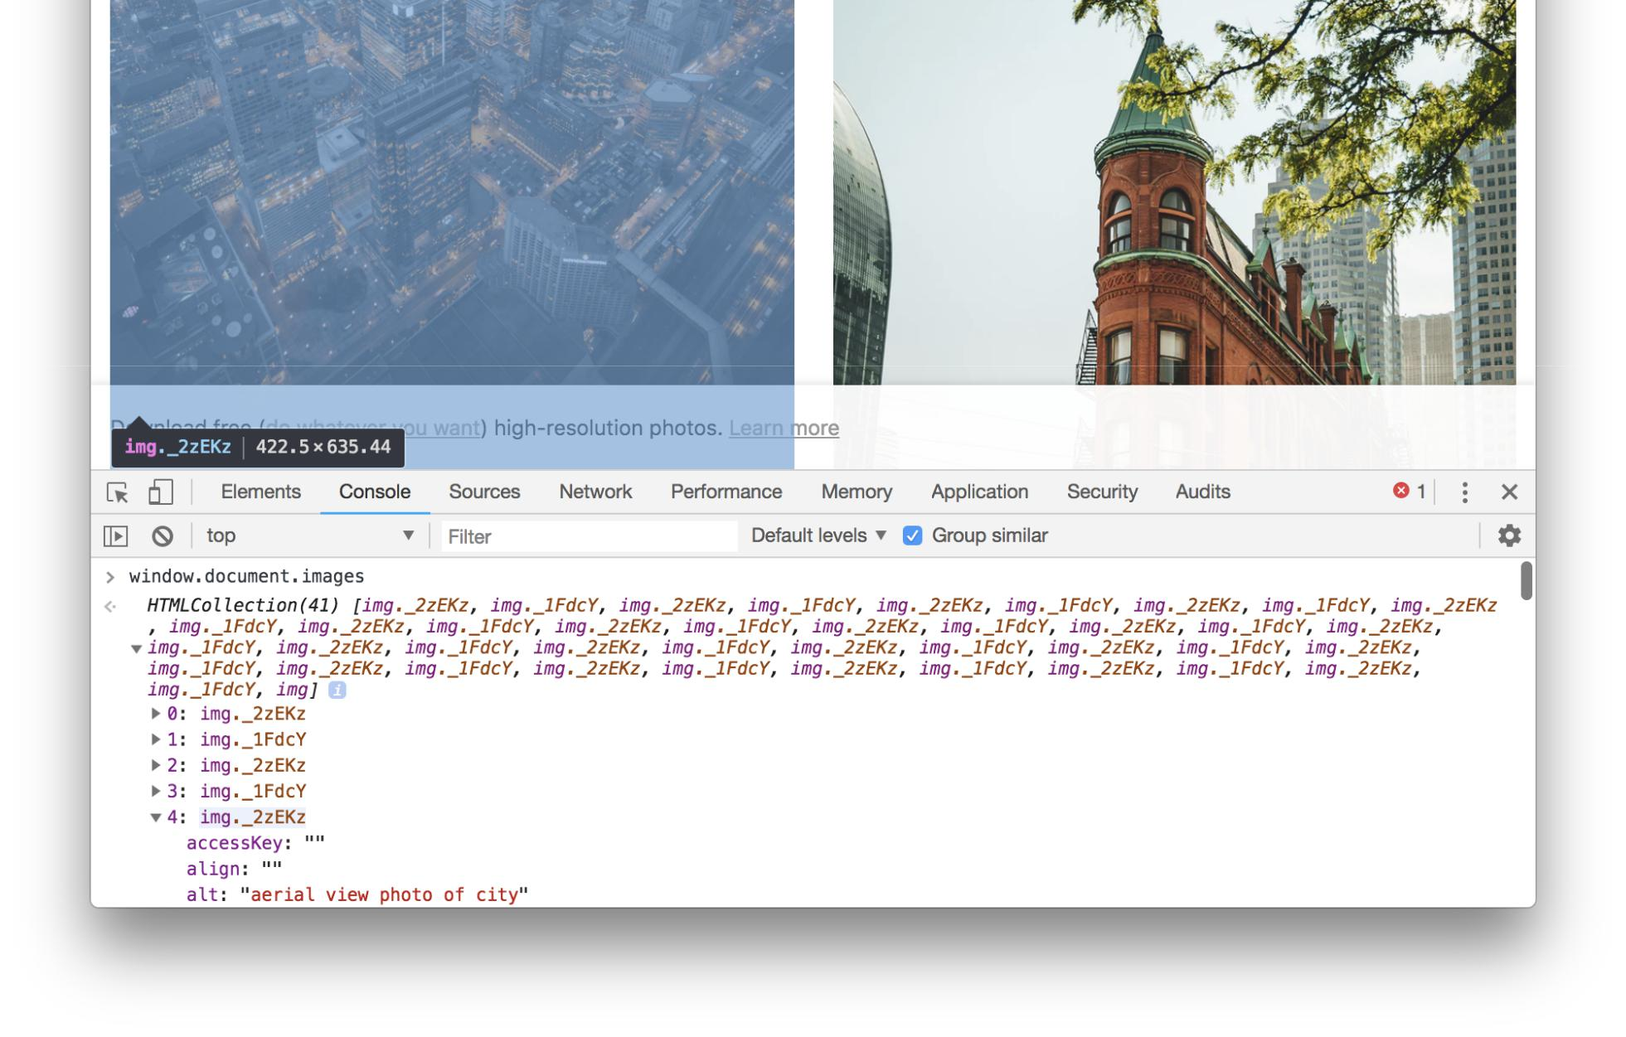

We can also use a number of methods to search for and get a reference to one or more elements in our document:

[document.getElementById(id)](https://developer.mozilla.org/en-US/docs/Web/API/Document/getElementById) - returns an element whose id attribute/property has the given id String



https://web222.ca/weeks/week07/ 10/32

2020. 7. 9. WEB222 - Week 7 | web222

<div id="menu">...</div>

<script>

**var** menuDiv **=** document.getElementById('menu');

</script>

[document.querySelector(selectors)](https://developer.mozilla.org/en-US/docs/Web/API/Document/querySelector) - similar to document.getElementById(id) , but also allows querying the DOM using [CSS selectors](https://developer.mozilla.org/en-US/docs/Web/CSS/CSS_Selectors) for an element that doesn’t have a unique id:



<div id="menu">

<p class="formatted">...</p>

</div>

<script>

* *We can specify we want to query by ID using a leading #* **var** menuDiv **=** document.querySelector('#menu');
* *We can specify we want to query by CLASS name using a leading .* **var** para **=** document.querySelector('.formatted');

</script>

[document.querySelectorAll(selectors)](https://developer.mozilla.org/en-US/docs/Web/API/Document/querySelectorAll) - similar to document.querySelector(selector) , but returns *all* elements that match the



selectors as a [NodeList](https://developer.mozilla.org/en-US/docs/Web/API/NodeList) :

<div id="menu">

<p class="formatted">Paragraph 1...</p>

<p class="formatted">Paragraph 2...</p>

<p class="formatted">Paragraph 3...</p>

</div>

<script>

* *Get all* **<**p**>**elements**in**thedocument**as**a list**var** pElements **=** document.querySelectorAll('p');
* *Loop through all returned* **<**p**>**elements**in**our listpElements.forEach(**function**(p) {
  + *p is one of the returned* **<**p**>**elements

});

</script>

https://web222.ca/weeks/week07/ 11/32

2020. 7. 9. WEB222 - Week 7 | web222

These four methods will work in any situation where you need to get a reference to something in document. In fact, you could rely solely on document.querySelector() and document.querySelectorAll() , which cover the same functionality as a number of other DOM methods:

* *The following two lines of code do exactly the same thing.*
* *NOTE the use of # to indicate `demo` is an id in the second example.* **var** elem **=** document.getElementById('demo');

**var** elem **=** document.querySelector('#demo');

**Creating elements and Modifying the DOM with JavaScript**

In addition to searching through the DOM using JavaScript, we can also make changes to it. The DOM provides a number of methods that allow use to create new content:

[document.createElement(name)](https://developer.mozilla.org/en-US/docs/Web/API/Document/createElement) - creates and returns a new element of the type specified by name .



**var** paragraphElement **=** document.createElement('p');

**var** imageElement **=** document.createElement('img');

[document.createTextNode(text)](https://developer.mozilla.org/en-US/docs/Web/API/Document/createTextNode) - creates a text node (the text within an element vs. the element itself).



**var** textNode **=** document.createTextNode('This is some text to show in an element');

These methods create the new nodes, but do not place them into the page. To do that, we first need to find the correct position within the exsting DOM tree, and then add our new node. We have to be clear *where* we want the new element to get placed in the DOM.

For example, if we want to place a node at the end of the <body> , we could use .appendChild() :

**var** paragraphElement **=** document.createElement('p');

document.body.appendChild(paragraphElement);

https://web222.ca/weeks/week07/ 12/32

2020. 7. 9. WEB222 - Week 7 | web222

If we instead wanted to place it within an existing <div id="content"> , we’d do this:

**var** paragraphElement **=** document.createElement('p');

**var** contentDiv **=** document.querySelector('#content');

contentDiv.appendChild(paragraphElement);

Both examples work the same way: given a parent node ( document or <div id="content"> ), add (append to the end of the list of children) our new element.

We can also use .insertBefore(new, old) to accomplish something similar: add our new node before the old (existing) node in the

DOM:

**var** paragraphElement **=** document.createElement('p');

**var** contentDiv **=** document.querySelector('#content');

**var** firstDivParagraph **=** contentDiv.querySelector('p');

contentDiv.insertBefore(paragraphElement, firstDivParagraph);

Removing a node is similar, and uses removeChild() :

*// Remove a loading spinner*

**var** loadingSpinner **=** document.querySelector('#loading-spinner');

* *Get a reference to the loading spinner's parent element* **var** parent **=** loadingSpinner.parentNode;parent.removeChild(loadingSpinner);

**Examples**

1. Add a new heading to a document

*// Create a new <h2> element*

**var** newHeading **=** document.createElement('h2');

https://web222.ca/weeks/week07/ 13/32

2020. 7. 9. WEB222 - Week 7 | web222

* *Add some text to the <h2> element we just created.*
* *Similar to doing <h2>This is a heading</h2>.*

**var** textNode **=** document.createTextNode('This is a heading');

* + *Add the textNode to the heading's child list* newHeading.appendChild(textNode);
  + *Insert our heading into the document, at the end of <body>* document.body.appendChild(newHeading);

1. Create a new paragraph and insert into the document

<div id="demo"></div>

<script>

* *Create a* **<**p**>**element

**var** pElem **=** document.createElement('p');

* *Use .innerHTML to create text nodes inside our* **<**p**>**...**<**/p>pElem.innerHTML **=** 'This is a paragraph.';
* *Get a reference to our* **<**div**> with**id**=**demo

**var** demoDiv **=** document.querySelector('#demo');

* *Append our* **<**p**>**element to the**<**div**>**demoDiv.appendChild(pElem);

</script>

**Inspecting, Modifying a DOM element with JavaScript**

Once we have a reference to an element in JavaScript, we use a number of properties and methods to work with it.

[**Element Properties**](https://developer.mozilla.org/en-US/docs/Web/API/Element#Properties)

element.id - the id of the element. For example: <p id="intro"></p> has an id of "intro" .



https://web222.ca/weeks/week07/ 14/32

2020. 7. 9. WEB222 - Week 7 | web222

element.innerHTML - gets or sets the markup contained within the element, which could be text, but could also include other HTML tags.



element.parentNode - gets a reference to the parent node of this element in the DOM.



element.nextSibling - gets a refernce to the sibling element of this element, if any.



element.className - gets or sets the value of the class attribute for the elmenet.



[**Element Methods**](https://developer.mozilla.org/en-US/docs/Web/API/Element#Methods)

element.querySelector() - same as document.querySelector() , but begins searching from element vs. document element.querySelectorAll() - same as document.querySelectorAll() , but begins searching from element vs. document



element.scrollIntoView() - scrolls the page until the element is in view.



element.hasAttribute(name) - checks if the attribute name exists on this element element.getAttribute(name) - gets the value of the attribute name on this element element.setAttribute(name, value) - sets the value of the attribute name on this element element.removeAttribute(name) - removes the attribute name from this element



**Examples**

1. Reveal an error message in the page, by removing an element’s hidden attribute

*<!-- The `hidden` attribute means this <div> won't be displayed until it's removed -->* <div id="error-message" hidden>

<p>There was an error saving the document. Please try again!</p>

</div>

<script>

* *Try to save the file, and* **var** error **=** saveFile(); **if**(error) {

**var** elem **=** document.querySelector('#error-message');elem.removeAttribute('hidden');

https://web222.ca/weeks/week07/ 15/32

2020. 7. 9. WEB222 - Week 7 | web222

}

</script>

1. Insert a user’s profile picture into the page
   * *Insert the user's picture (e.g., in response to hovering over a username)* **var** profilePic **=** document.createElement('img');
   * *Set attributes via getters/setters on the element vs. attributes* profilePic.id **=** 'user-' **+** username;

profilePic.height **=** 50;

profilePic.src **=** './images/' **+** username **+** '-user-profile.jpg';

* + *Insert the profile pic <img> into the document*

document.body.appendChild(profilePic);

* + *Make sure the new image is visible, or scroll until it is* profilePic.scrollIntoView();

1. Add new paragraph elements to a div
   * *Use .innerHTML as a getter and setter to update some text* **var** elem **=** document.querySelector('#text');

elem.innerHTML **=** '<p>This is a paragraph</p>';

elem.innerHTML **=** elem.innerHTML **+** '<p>This is another paragraph</p>';

**Events**

The DOM relies heavily on a concept known as [event-driven programming](https://en.wikipedia.org/wiki/Event-driven_programming). In event-driven programs, a main loop (aka the *event loop*), processes events as they occur.

https://web222.ca/weeks/week07/ 16/32

element.addEventListener('click', function(e) {...});

element.onclick = function(e) {...};

Consider the following code:

In the second method above, use

2020. 7. 9. WEB222 - Week 7 | web222

Examples of events include things like user actions (clicking a button, moving the mouse, pressing a key, changing tabs in the browser), or browser/code initiated actions (timers, messages from background processes, reports from sensors).

Instead of writing a program in a strict order, we write functions that should be called in response to various events occurring. Such functions are often referred to as *event handlers*, because they handle the case of some event happening. If there is no event handler for a given event, when it occurs the browser will simply ignore it. However, if one or more event handlers are registered to listen for this event, the browser will call each event handler’s function in turn.

You can think of events like light switches, and event handlers like light fixtures: flipping a light switch on or off triggers an action in the light fixture, or possibly in multiple light fixtures at once. The lights handle the event of the light switch being flipped.



DOM programming is typically done by writing many functions that execute in response to events in the browser. We register our event handlers to indicate that we want a particular action to occur. DOM events have a name we use to refer to them in code.

We can register a DOM event handler for a given event in one of two ways:

1. element.onevent = function(e) {...};
2. element.addEventListener('event', function(e) {...}) and element.removEventListener('event', function(e) {...})

In both cases above, we first need an HTML element. Events are emitted to a *target* element. Elements in the DOM can trigger one or more events, and we must know the name of the event we want to handle.

In the first method above, element.onevent = function(e) {...}; , a single event handler is registered for the event event connected with the target element element . For example, document.body.onclick = function(e) {...}; , indicates we want to register an event handler for the click event on the document.body element (i.e., <body>...</body> ).

addEventListener() to add as many individual, separate event handlers as we need. Whereas

binds a single event handler (function) to the click event for element , using

*adds* a new event handler (function) to any that might already exist.

https://web222.ca/weeks/week07/ 17/32

2020. 7. 9. WEB222 - Week 7 | web222

**var** body **=** document.body;

**function** handleClick(e) {

*// Process the click event*

}

**function** handleClick2(e) {

*// Another click handler*

}

body.onclick **=** handleClick;

body.onclick **=** handleClick2;

*// There is only 1 click event handler on body: handleClick2 has replaced handleClick.*

body.addEventListener('click', handleClick);

body.addEventListener('click', handleClick2);

*// There are now multiple, unique click handlers bound to the body's click event.*

Because addEventListener() is more versatile than the older onevent properties, you are encouraged to use it in most cases.

Here’s an example of the first method, where we only need a single event handler. In the following case, a web page has a Save button, and we want to save the user’s work when she clicks it.

<button id='btn-save'>Save</button>

<script>

*// Get a reference to our Save* **<**button**>**

**var** saveBtn **=** document.querySelector('#btn-save');

**function** save() {

*// Save the user's work*

}

* *Register a single event handler on the save button's click event* saveBtn.onclick **= function**(e) {

https://web222.ca/weeks/week07/ 18/32

2020. 7. 9. WEB222 - Week 7 | web222

* *Save the user's work, calling a save() function we wrote elsewhere* save();

};

</script>

Now consider the same code, but with multiple event handlers. In this case we not only want to save the user’s work, but also log the information in our web analytics so we can keep track of how popular this feature is (how many times it gets clicked):

<span id="needs-saving">Document has changes, Remember to Save!</span>

...

<button id='btn-save'>Save</button>

<script>

*// Get a reference to our Save* **<**button**>**

**var** saveBtn **=** document.querySelector('#btn-save');

* *Register first event handler on the save button's click event* saveBtn.addEventListener('click', **function**(e) {
  + *Save the user's work, calling a save() function we wrote elsewhere* save();
  + *Remove the "needs to be saved" info showing in our UI, since we've saved* document.querySelector('#btn-save').setAttribute('hidden', **true**);

});

* *Register second event handler on the save button's click event* saveBtn.addEventListener('click', **function**(e) {
  + *Log some info to the console for debugging.*

console.log('[DEBUG] Save clicked');

* *Use an analytics Object (defined elsewhere) to update our count for this event* analytics.increment('save');

});

</script>

https://web222.ca/weeks/week07/ 19/32

2020. 7. 9. WEB222 - Week 7 | web222

In this second example, it’s possible for the browser to call more than one function (event handler) in response to a single event ( click ). What’s nice about this is that different parts of our code don’t have to be combined into a single function. Instead, we can keep things separate (saving logic vs. analytics logic).

A complete example of a page that listens for changes to the network online/offline status, and updates the page accordingly, is available at [online.html](https://web222.ca/weeks/week07/online.html).

**Common Events**

There are [many types of events we can listen for in the DOM](https://developer.mozilla.org/en-US/docs/Web/Events), some of which are very specialized to certain elements or Objects. However, there some common ones we’ll use quite often:

[load](https://developer.mozilla.org/en-US/docs/Web/Events/load) - fired when a resource has finished loading (e.g., a window , img )



[beforeunload](https://developer.mozilla.org/en-US/docs/Web/Events/beforeunload) - fired just before the window is about to be unloaded (closed)



[focus](https://developer.mozilla.org/en-US/docs/Web/Events/focus) - when the element receives focus (cursor input)



[blur](https://developer.mozilla.org/en-US/docs/Web/Events/blur) - when the element loses focus



[click](https://developer.mozilla.org/en-US/docs/Web/Events/click) - when the user single clicks on an element



[dblclick](https://developer.mozilla.org/en-US/docs/Web/Events/dblclick) - when the user double clicks on an element



[contextmenu](https://developer.mozilla.org/en-US/docs/Web/Events/contextmenu) - when the right mouse button is clicked



[keypress](https://developer.mozilla.org/en-US/docs/Web/Events/keypress) - when a key is pressed on the keyboard



[change](https://developer.mozilla.org/en-US/docs/Web/Events/change) - when the content of an element changes (e.g., an input element in a form)



[mouseout](https://developer.mozilla.org/en-US/docs/Web/Events/mouseout) - when the user moves the mouse outside the element



[mouseover](https://developer.mozilla.org/en-US/docs/Web/Events/mouseover) - when the user moves the mouse over top of the element



[resize](https://developer.mozilla.org/en-US/docs/Web/Events/resize) - when the element is resized



All of the events described above can be used in either of the two ways we discussed above. For example, if we wanted to use the mouseout event on an element:

https://web222.ca/weeks/week07/ 20/32

2020. 7. 9. WEB222 - Week 7 | web222

<div id="map">...</div>

<script>

**var** map **=** document.querySelector('map');

* *Method 1: register a single event handler via the on* property* map.onmouseout **= function**(e) {
  + *do something here in response to the mouseout event on this div.*

}

* *Method 2: register one of perhaps many event handlers via addEventListener* map.addEventListener('mouseout', **function**(e) {
  + *do something here in response to the mouseout event on this div.*

});

</script>

**The** [**Event Object**](https://developer.mozilla.org/en-US/docs/Web/API/Event)

In the example code above, you may have noticed that our event handler functions often looked like this:

element.onclick **= function**(e) {

*// e is an instance of the Event object*

}

The single e argument is an instance of the [Event Object](https://developer.mozilla.org/en-US/docs/Web/API/Event). The e or event is provided to our event handler function in order to pass information about the event, and to give us a chance to alter what happens next.

For example, we can get a reference to the element to which the event was dispatched using [e.target](https://developer.mozilla.org/en-US/docs/Web/API/Event/target) . We can also instruct the browser to prevent the “default” action from happening as a result of this event using [e.preventDefault()](https://developer.mozilla.org/en-US/docs/Web/API/Event/preventDefault) , or stop the event from continuing to *bubble* up the DOM (i.e., rise up the DOM tree nodes, triggering other event handlers along the way) using[`e.stopPropagation()](https://developer.mozilla.org/en-US/docs/Web/API/Event/stopPropagation).

Here’s an example showing how to use these:

https://web222.ca/weeks/week07/ 21/32

2020. 7. 9. WEB222 - Week 7 | web222

<button id="btn">Click Me</button>

<script>

document.querySelector('#btn').addEventListener('click', **function**(e) {

* *Prevent this event from doing anything more, we'll handle it all here.* e.preventDefault();

e.stopPropagation();

* *Get a reference to the* **<**button**>**element

**var** btn **=** e.target;

* *Change the text of the button* btn.innerHTML **=** "You clicked Me!"

});

</script>

Some events also provide specialized (i.e., derived from Event ) event Objects with extra data on them related to the context of the event.

For example, a [MouseEvent](https://developer.mozilla.org/en-US/docs/Web/API/MouseEvent) gives extra detail whenever a click, mouse move, etc. event occurs:

<div id="position"></div>

<script>

document.body.addEventListener('click', **function**(e) {

* *Get extra info about this mouse event so we know where the pointer was* **var** x **=** e.screenX;

**var** y **=** e.screenY;

* *Display co-ordinates where the mouse was clicked: "Position (300, 342)"* document.querySelector('#position').innerHTML **=** `Position (${x}, ${y})`

});

</script>

**Timers**

https://web222.ca/weeks/week07/ 22/32

2020. 7. 9. WEB222 - Week 7 | web222

It’s also possible for us to write an event handler that happens in response to a timing event (delay) vs. a user or browser event. Using these timing event handlers, we scheduling a task (function) to run after a certain period of time has elapsed:

setTimeout(function, delayMS) - schedule a task ( function ) to be run in the future ( delayMS milliseconds from now). Can be cancelled with clearTimeout(timerID)



setInterval(function, delayMS) - schedule a task ( function ) to be run in the future every delayMS milliseconds from now. Function will be called repeatedly. Can be cancelled with clearInterval(timerID)



Here’s an example of using an interval to update a web page with the current date and time every 1 second.

<p hidden>The current date and time is <time id="current-date"></time></p> <button id="btn-start">Start Timer</button> <button id="btn-end">End Timer</button>

<script>

**var** startButton **=** document.querySelector('#btn-start');

**var** endButton **=** document.querySelector('#btn-end');

**var** timerId;

* *When the user clicks Start, start our timer* startButton.onclick **= function**(e) {
  + *If the user clicks it more than once, ignore it once it's running* **if**(timerId) {

**return**;

}

**var** currentDate **=** document.querySelector('#current-date');

currentDate.removeAttribute('hidden');

* *Start our timer to update every 1000ms (1s), showing the current date/time.* timerId **=** setInterval(**function**() {

**var** now **= new** Date();

currentDate.innerHTML **=** now.toLocaleString(); }, 1000);

};

https://web222.ca/weeks/week07/ 23/32

2020. 7. 9. WEB222 - Week 7 | web222

endButton.onclick **= function**(e) {

* *If the user clicks End when the timer isn't running, ignore it.* **if**(**!**timerId) {

**return**;

}

* *Stop the timer*

clearInterval(timerId);

timerId **= null**;

};

</script>

**DOM Programming Exercise**



In this exercise, we will practice working with HTML, images, URLs, the DOM, events, and JavaScript to create an interactive web page.

1. Create a **folder** called cats on your computer
2. Create a **file** inside the cats folder named index.html
3. Open a **terminal** to your cats folder (i.e., cd cats )
4. In your **terminal**, start a web server by running the following command: npx http-server
5. Open the cats folder in Visual Studio Code
6. Edit the index.html file so it contains a [basic HTML5 web page](https://web222.ca/weeks/week05/#basic-html5-document), including a <head> , <body> , etc. Try to do it from memory first, then look up what you’ve missed.
7. Save index.html and try loading it in your browser by visiting your local web server at http://localhost:8080/index.html
8. In your editor, modify the body of your index.html file to contain the text of the poem in [cats.txt](https://web222.ca/weeks/week07/cats.txt). Use HTML tags to markup the poem for the web. Your page should have a proper heading for the title, each line should break at the correct position, and the poet’s name should be bold.
9. Add an image of a cat to the page below the text. You can use <https://upload.wikimedia.org/wikipedia/commons/c/c1/Six_weeks_old_cat_%28aka%29.jpg>.
10. Adjust the width of your image so it fits nicely on your page. What happens if you adjust the width and height ?

https://web222.ca/weeks/week07/ 24/32

2020. 7. 9. WEB222 - Week 7 | web222

11. Create a new file in your cats folder called script.js . Add the following line of JavaScript:

console.log('cats!');

12. Add a script element to the bottom of your body (i.e., right before the closing </body> tag). Set its src to a file called script.js :

<script src="script.js"></script>

</body>

1. Refresh your web page in the browser, and open your browser’s Dev Tools , and Web Console . Make sure you can see the cats! message printed in the log.
2. Try changing cats! in script.js to some other message, save your script.js file, and refresh your browser. Make sure your console updates with the new message.
3. Modify index.html and update your <img> tag: add an attribute id="cat-picture" and remove the src="..." :

*<!-- NOTE: there is no longer a src attribute in our HTML, we'll do it JavaScript below -->* <img id="cat-picture">

16. Modify your script.js file to add the following code:

window.onload **= function**() {

**var** img **=** document.getElementById('cat-picture');

img.src **=** 'https://upload.wikimedia.org/wikipedia/commons/c/c1/Six_weeks_old_cat_%28aka%29.jpg';

};

1. Save your script.js file and reload your browser. Do you still see a cat? If not, check your web console for any errors.
2. Modify your script.js and change your cat URL used by img.src to use <https://cataas.com/cat>. The [cataas.com](https://cataas.com/#/) site provides cat pictures as a service via URL parameters. Save script.js and reload your page a few times. Do you see a different cat each time?

https://web222.ca/weeks/week07/ 25/32

2020. 7. 9. WEB222 - Week 7 | web222

1. Modify your script.js file to move your image code to a separate function. Make sure it still works the same way when you’re done (save and test in your browser):

**function** loadCatPicture() {

**var** img **=** document.getElementById('cat-picture');

img.src **=** 'https://cataas.com/cat';

}

window.onload **=** loadCatPicture;

20. Rewrite script.js to update the picture after 5 seconds:

**function** loadCatPicture() {

**var** img **=** document.getElementById('cat-picture');

img.src **=** 'https://cataas.com/cat';

}

window.onload **= function**() {

loadCatPicture();

* *Call the loadCatPicture function again in 5000ms* setTimeout(loadCatPicture, 5 **\*** 1000 */* 5s = 5000ms */*);

};

21. Rewrite script.js to update the picture every 15 seconds, forever:

**function** loadCatPicture() {

**var** img **=** document.getElementById('cat-picture');

img.src **=** 'https://cataas.com/cat';

}

window.onload **= function**() {

loadCatPicture();

https://web222.ca/weeks/week07/ 26/32

2020. 7. 9. WEB222 - Week 7 | web222

* *Call the loadCatPicture function every 15000ms* setInterval(loadCatPicture, 15 **\*** 1000 */* 15s = 15000ms */*);

};

22. Rewrite script.js to update the picture only when the user clicks somewhere in the window:

**function** loadCatPicture() {

**var** img **=** document.getElementById('cat-picture');

img.src **=** 'https://cataas.com/cat';

}

window.onload **= function**() {

loadCatPicture();

* *Call the loadCatPicture function when the user clicks in the window* window.onclick **=** loadCatPicture;

};

23. Modify index.html and put a <div>...</div> around all the text of the poem. Give your div an id="poem-text" attribute:

<div id="poem-text">

<p>Cats sleep anywhere, any table, any chair....</p>

...

</div>

24. Rewrite script.js to load the picture only when the user clicks on the text of the poem:

**function** loadCatPicture() {

**var** img **=** document.getElementById('cat-picture');

img.src **=** 'https://cataas.com/cat';

}

https://web222.ca/weeks/week07/ 27/32

2020. 7. 9. WEB222 - Week 7 | web222

**var** poemText **=** document.getElementById('poem-text');

poemText.onclick **=** loadCatPicture;

25. Rewrite script.js to also load the picture only when the user presses a key on the keyboard:

**function** loadCatPicture() {

**var** img **=** document.getElementById('cat-picture');

img.src **=** 'https://cataas.com/cat';

}

**var** poemText **=** document.getElementById('poem-text');

poemText.onclick **=** loadCatPicture;

window.onkeypress **= function**(event) {

**var** keyName **=** event.key;

console.log('Key Press event', keyName);

loadCatPicture();

};

26. Rewrite script.js to also load the picture only when the user presses a key on the keyboard, but only one of b, m, s, n, p, x :

**function** loadCatPicture() {

**var** img **=** document.getElementById('cat-picture');

img.src **=** 'https://cataas.com/cat';

}

**var** poemText **=** document.getElementById('poem-text');

poemText.onclick **=** loadCatPicture;

window.onkeypress **= function**(event) {

**var** keyName **=** event.key;

console.log('Key Press event', keyName);

**switch**(keyName) {

https://web222.ca/weeks/week07/ 28/32

2020. 7. 9. WEB222 - Week 7 | web222

**case** 'b':

**case** 'm':

**case** 's':

**case** 'n':

**case** 'p':

**case** 'x':

loadCatPicture();

**break**;

**default**:

console.log('Ignoring key press event');

}

};

1. Rewrite script.js to also load the picture only when the user presses a key on the keyboard, but only one of b, m, s, n, p, x , and load the picture with one of the supported [cataas filters](https://cataas.com/#/):

**function** loadCatPicture(filter) {

**var** url **=** 'https://cataas.com/cat';

**var** img **=** document.getElementById('cat-picture');

* *If the function is called with a filter argument, add that to URL* **if** (filter) {

console.log('Using cat picture filter', filter); url **+=** '?filter=' **+** filter

}

img.src **=** url;

}

**var** poemText **=** document.getElementById('poem-text');

poemText.onclick **= function**() {

loadCatPicture();

};

window.onkeypress **= function**(event) {

https://web222.ca/weeks/week07/ 29/32

2020. 7. 9. WEB222 - Week 7 | web222

**var** keyName **=** event.key;

console.log('Key Press event', keyName);

**switch**(keyName) {

**case** 'b':

**return** loadCatPicture('blur');

**case** 'm':

**return** loadCatPicture('mono');

**case** 's':

**return** loadCatPicture('sepia');

**case** 'n':

**return** loadCatPicture('negative');

**case** 'p':

**return** loadCatPicture('paint');

**case** 'x':

**return** loadCatPicture('pixel');

**default**:

console.log('Ignoring key press event');

}

};

1. Rewrite script.js so that we only load a new cat picture when the old picture is finished loading (don’t send too many requests to thh server). Also, add some [cache busting](https://www.keycdn.com/support/what-is-cache-busting):
   * *Demonstrate using a closure, and use an immediately executing function to hide*
   * *an `isLoading` variable (i.e., not global), which will keep track of whether*
   * *or not an image is being loaded, so we can ignore repeated requests.*

**var** loadCatPicture **=** (**function**() {

**var** isLoading **= false**;

* *This is the function that will be bound to loadCatPicture in the end.* **return function**(filter) {

**if**(isLoading) {

console.log('Skipping load, already in progress'); **return**;

https://web222.ca/weeks/week07/ 30/32

2020. 7. 9. WEB222 - Week 7 | web222

}

**var** img **=** document.getElementById('cat-picture');

**function** finishedLoading() {

isLoading **= false**;

* *Remove unneeded event handlers so `img` can be garbage collected.* img.onload **= null**;

img.onerror **= null**; img **= null**;

}

img.onload **=** finishedLoading;

img.onerror **=** finishedLoading;

* *If the function is called with a filter argument, add that to URL* **var** url **=** 'https://cataas.com/cat';
* *Add something unique (and meaningless) to the query string, so the browser*
* *won't cache this URL, but always load it again*

url **+=** '?nocache=' **+** Date.now();

**if** (filter) {

console.log('Using cat picture filter', filter);

url **+=** '&filter=' **+** filter

}

* *Finally, set isLoading to true, and begin loading image* isLoading **= true**;

img.src **=** url;

};

})();

**var** poemText **=** document.getElementById('poem-text');

poemText.onclick **= function**() {

loadCatPicture();

};

https://web222.ca/weeks/week07/ 31/32

2020. 7. 9. WEB222 - Week 7 | web222

window.onkeypress **= function**(event) {

**switch**(event.key) {

**case** 'b':

**return** loadCatPicture('blur');

**case** 'm':

**return** loadCatPicture('mono');

**case** 's':

**return** loadCatPicture('sepia');

**case** 'n':

**return** loadCatPicture('negative');

**case** 'p':

**return** loadCatPicture('paint');

**case** 'x':

**return** loadCatPicture('pixel');

**default**:

console.log('Ignoring key press event');

**break**;

}

};



This site is open source. [Improve this page](https://github.com/sictweb/web222/edit/master/weeks/week07/README.md).

https://web222.ca/weeks/week07/ 32/32